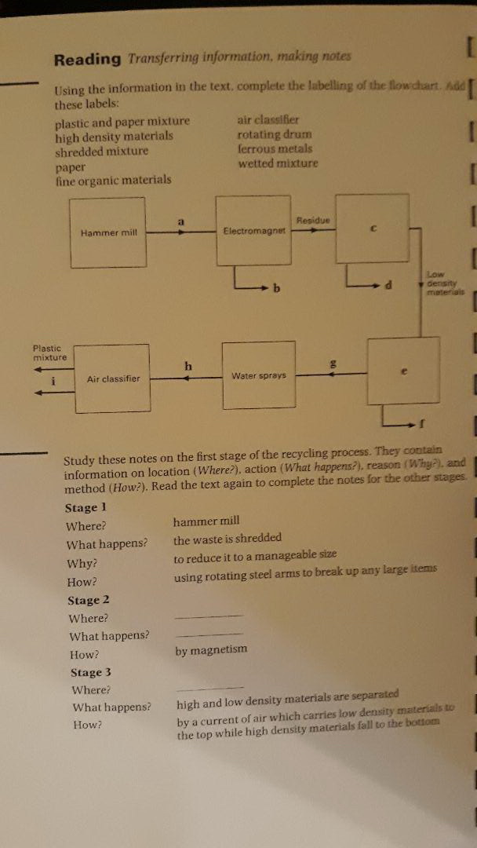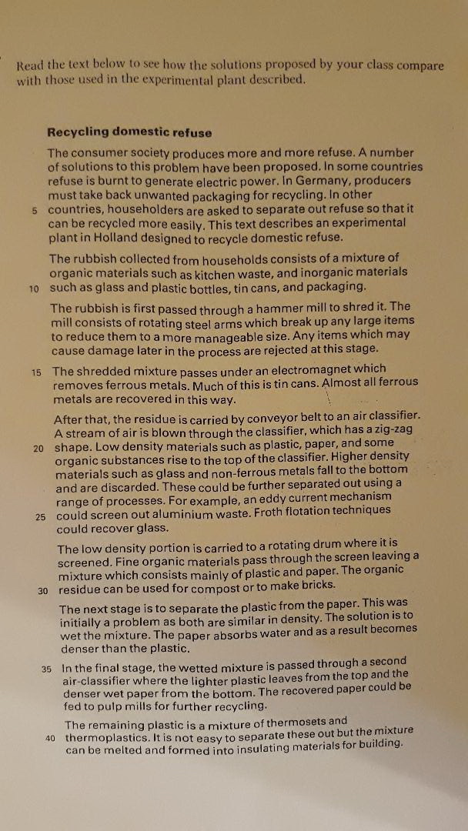
I First read the text on Recycling domestic refuse and then do the exercises on the first page.
Additional task: Watch one episode of How it is made? on the Youtube channel,
and then try to summarize the industrial processes you have seen there in one
paragraph by using your own words!

Past Continuous Question Answer Match
Match the numbered questions with the answers from the box.
1. What were you doing when the TV exploded? I was watching the afternoon movie.
2. Where was he going when his tire got a puncture? He was cycling to his mother's house.
3. Where was he when he found the abandoned kitten? He was working in the garden.
4. What was she doing on the bus when she found the wallet? She was traveling to work.
5. Who was he speaking to when he got the phone call from his wife? He was talking to his boss about his promotion.
6. What was the teacher doing when the fire alarm went off in the school? She was correcting the students' homework.
7. How fast was he driving when the accident happened?
I don't know, but I think he was going too fast.
8. What was the prisoner wearing when he escaped from the prison? He was wearing a blue prison uniform.

The Party
Read the following short text about a party and decide the best place in the text for the phrases which follow:
When I arrived at the party, there were many people there. First I saw Boris Yeltsin near the bar. Madonna was with some friends. Sting and Zucchero were near a big group of young girls. All the waiters were Mexican.
- and were talking to each other in Spanish
- and were singing a beautiful Italian song
- who was drinking a bottle of vodka
- and everybody was enjoying themselves
- and was singing her latest song

